Professional Readiness for Innovation, Employability and Entrepreneurship

Smart Home

Assignment 1

# Submitted by:

A.Farzana Fathima

962819106012

B1-1M3E

# CIRCUIT DIAGRAM FOR SMART HOME:

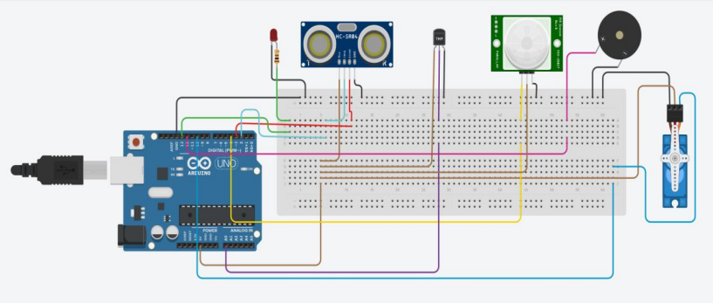

# CODING:

#include <Servo.h>

int location=0;

int i=0;

int j=0;

Servo s;

Void setup()

{

Serial.begin(9600);

pinMode(4,INPUT);

pinMode(13,OUTPUT);

pinMode(12,OUTPUT);

s.attach(10,500,2500);

pinMode(3,INPUT);

pinMode(2,OUTPUT);

}

void loop()

{

int n=digitalRead(4);

Serial.println(n);

If(n){

Serial.println(“MOTION DETECTD!!!”);

Location=0;

For(location=1;location<=180;location+=60){

s.write(location);

delay(100);

double a=analogRead(A0);

double t=(((a/1024)*5)-0.5)*100;

Serial.print(“TEMP VALUE:”);

Serial.println(t);

If(t>100){

for(int j=200;j<220;j++)

{

tone(12,j);

}

delay(1000);

noTone(12);

}

digitalWrite(2,LOW);

digitalWrite(2,HIGH);

delay(1000);

digitalWrite(2,Low);

float dur=pulseIn(3,HIGH);

digitalWrite(13,LOW);

if(dis<20){

Serial.print(“Distance”);

Serial.print(dis);

Serial.println(“cm”);

digitalWrite(13,HIGH);

}  
}

digitalWrite(2,LOW);

digitalWrite(2,HIGH);

delay(1000);

digitalWrite(2,Low);

float dur=pulseIn(3,HIGH);

float dis=(dur*0.0343)2;

digitalWrite(13,LOW);

if(dis<20){

Serial.print(“Distance”);

Serial.print(dis);

Serial.println(“cm”);

digitalWrite(13,HIGH);

}

}

delay(1000);

}